Physics 30 1997 June
- The physical quantity that can have the same unit as impulse is
A. force
B. work
C. power
D. momentum

Use the following information to answer the next two questions.

A 5.00 kg object is dropped from a height above the ground. When the object is 4.00 m from the ground, it has a speed of 9.00 m/s. The potential energy of the object is chosen to be zero at ground level and the effects of air resistance are ignored.

- What is the total mechanical energy of the falling object?
A. 6.30 J
B. 196 J
C. 202 J
D. 399 J

Use your recorded answer for Multiple Choice 2 to solve Numerical Response 1.

Numerical Response

- The object was dropped from an initial height of __________ m above the ground.

(Record your three-digit answer in the numerical-response section on the answer sheet.)

- A space shuttle astronaut has a mass of 110 kg with her space suit on. She is on a space walk and picks up a full can of spray with a mass of 20 kg. Relative to the space shuttle, she is at rest. She then holds the can directly in front of her centre of mass to avoid rotation and releases 3.0 kg of spray at a speed of 15 m/s. Her speed, relative to the space shuttle, when she has stopped spraying is approximately
A. 0.35 m/s
B. 0.41 m/s
C. 2.3 m/s
D. 2.5 m/s

Use the following information to answer the next question.

A popular game of young children is to shuffle across a carpet with stocking feet and then touch a friend. The spark that can be generated is caused by a charge buildup from the friction of the socks on the carpet.

- Two friends, Sam and Jeff, shuffled on a carpet and obtained approximately the same negative charge. They then stood shoulder to shoulder without touching. A third friend, Cale, who was not charged, touched Jeff on the shoulder farthest from Sam. What is the nature of the final charges on the three boys?
A. Sam, Jeff, and Cale are all negatively charged.
B. Jeff and Cale are uncharged, and Sam is negatively charged.
C. Sam and Cale are negatively charged, and Jeff is positively charged.
D. Sam is negatively charged, and Jeff and Cale are positively charged.
______________________________

- Three pithballs hang in an isolated container. Ball X has a charge of 1.0 x 10⁻⁹ C, and balls Y and Z are neutral. Ball X is brought momentarily into contact with ball Y, then separated. Ball Y is then brought momentarily into contact with ball Z, then separated. When placed 1.0 m apart, balls X and Z will now exert a force on each other of magnitude
A. 1.0 x 10⁻⁹ N
B. 1.1 x 10⁻⁹ N
C. 2.2 x 10⁻⁹ N
D. 9.0 x 10⁻⁹ N

Numerical Response

- Two charged bodies exert electrostatic forces on each other of magnitude 1.11 x 10⁻⁴ N. If the magnitude of each charge is doubled and the distance separating them is doubled, then the magnitude of the electrostatic force, expressed in scientific notation, is b x 10^{-w} N. The value of b is __________.

(Record your three-digit answer in the numerical-response section on the answer sheet.)

Numerical Response

- In moving an electric charge of 4.00 C from point X to point Y, 15.0 J of work is done. The potential difference between X and Y, in volts, is __________ V.

(Record your three-digit answer in the numerical-response section on the answer sheet.)

Use the following information to answer the next question.

Light Bulbs
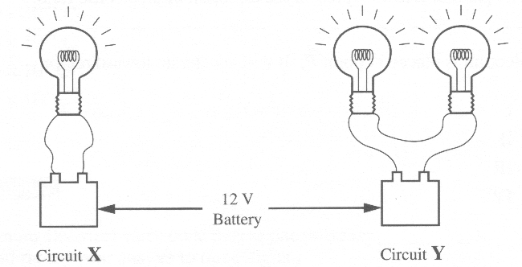
The bulbs have identical resistances, and the batteries are identical.

- Which of the following statements best describes the diagram above?
A. Circuit Y dissipates more power than does circuit X.
B. The current in circuit Y is larger than the current in circuit X.
C. The current in circuit Y is the same as the current in circuit X.
D. The current in circuit Y is smaller than the current in circuit X.

Use the following information to answer the next question.

Electric Field
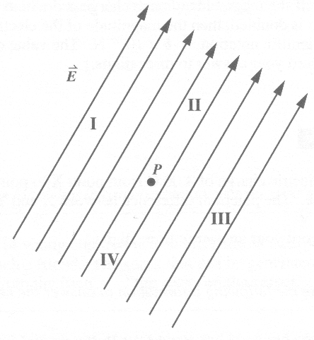
The parallel arrows represent the direction of an electric field.

- An electron is placed at point P. It will accelerate toward region
A. I
B. II
C. III
D. IV
_____________________________

- The volt is the SI unit of potential difference. An equivalent SI unit may be written as
A. J/A
B. J/C
C. N/C
D. A/Ω

- Which of the following is a definition of conventional direct current?
A. A movement of negative charge in one direction only
B. A movement of positive charge in one direction only
C. A shift of negative charge that reaches a peak in the forward direction before reversing and reaching a peak in the reverse direction
D. A shift of positive charge that reaches a peak in the forward direction before reversing and reaching a peak in the reverse direction

Use the following information to answer the next two questions.

Torpedo occidentalis is a large electric fish that uses electricity in attack and defense. A typical individual fish is capable of producing potential differences of up to 220 V and of generating pulses of 15.0 A current through its seawater environment. Pulses are typically 2.00 x 10⁻³ s in duration.

- The total charge transferred by the fish in one of these pulses is
A. 3.00 x 10⁻² C
B. 4.40 x 10⁻¹ C
C. 3.00 x 10³ C
D. 3.30 x 10³ C

Numerical Response

- The maximum electrical work done during one pulse is __________ J.

(Record your three-digit answer in the numerical-response section on the answer sheet.)

- If the resistance of a circuit is halved and the voltage applied to the circuit is doubled, then the current in the circuit is
A. the same
B. quartered
C. doubled
D. quadrupled

Use the following information to answer the next four questions.

Electric Circuit
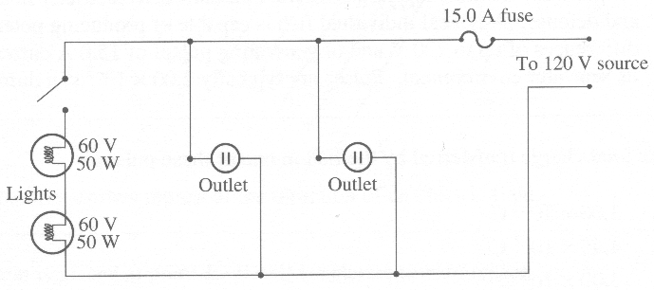

The above diagram represents a possible electric circuit in a home. (Assume the wires are of negligible resistance.)

- When the switch is closed, the above circuit can be correctly described as
A. two series lights, in series with the two outlets
B. two parallel lights, in series with the two outlets
C. two series lights, in parallel with the two outlets
D. two parallel lights, in parallel with the two outlets

- A 1.00 x 10³ W toaster is plugged into one outlet of the circuit and switched on. Both lights are on. The maximum power rating for a kettle that could be plugged into the other outlet and switched on without burning out the fuse is
A. 7.00 x 10² W
B. 8.00 x 10² W
C. 1.00 x 10³ W
D. 1.50 x 10³ W

Numerical Response

- When a 1.00 x 10³ W toaster is plugged into one of the outlets, the current in the toaster is ___________ A.

(Record your three-digit answer in the numerical-response section on the answer sheet.)

Numerical Response

- At a rate of 6.71 ¢/(kW·h), the cost of operating the 1.00 x 10³ W toaster for 1.10 minutes a day for 30 days is __________ ¢.

(Record your three-digit answer in the numerical-response section on the answer sheet.)

Use the following information to answer the next three questions.

Mass Spectrometer

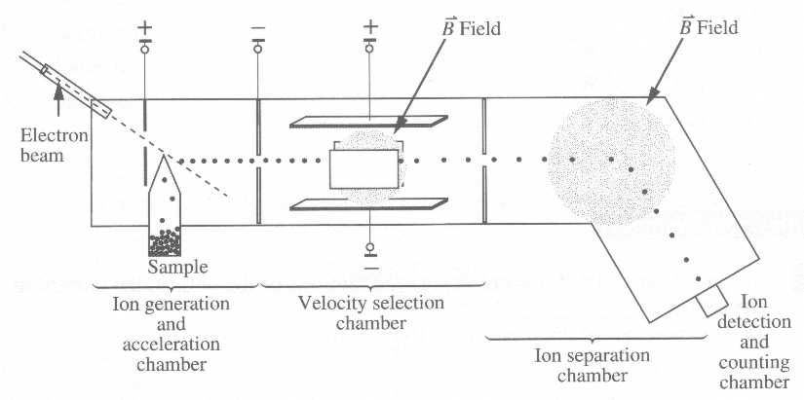

A biochemist uses a mass spectrometer to identify pollutants in a water sample. A mass spectrometer typically consists of four chambers, as shown above.

- Why do ions of only a certain speed pass through the velocity selection chamber undeflected?
A. Only these ions possess the charge needed to be undeflected by the fields.
B. The electric field strength is the same as the magnetic field strength.
C. Ions travelling at other speeds have insufficient E_{k} to pass through the chamber.
D. The net deflecting force, from the electric and magnetic fields, is zero for only these ions.

Use the following additional information to answer the next two questions.

The biochemist has the spectrometer set as follows:

Velocity selection chamber: 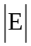 = 2.17 x 10⁴ V/M
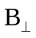= 9.00 x 10⁻³ T

Ion separation chamber: = 1.40 T
deflecting radius = 1.00 m

At these settings, an ion is detected. The biochemist expects the ion to be one of the ions listed below. The mass corresponding to each ion is given.

Cr²⁺ 8.64 x 10⁻²⁶ kg
Cd²⁺ 1.86 x 10⁻²⁵ kg
Hg²⁺ 3.33 x 10⁻²⁵ kg
Pb²⁺ 3.44 x 10⁻²⁵ kg

- Which of the above pollutants is detected by the spectrometer?
A. Cr²⁺
B. Cd²⁺
C. Hg²⁺
D. Pb²⁺

Use the following additional information to answer the next question.

In the ion generation and acceleration chamber, atoms in the sample are ionized by bombarding them with electrons to remove outermost electrons. The biochemist must have the accelerating voltage in the electron gun set high enough to ensure ionization of the particles.

- Which of the following physical principles must be used to calculate the value of the accelerating voltage in the electron gun?
A. Ohm's law
B. Coulomb's law
C. Conservation of energy
D. Conservation of momentum

Use the following information to answer the next two questions.

Current Overload
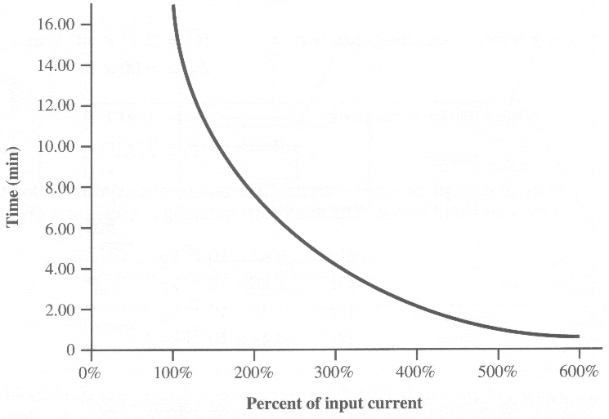
An electric motor needs to be protected from overheating. The graph shows the time at which motor shutdown will occur due to overloading and overheating for currents greater than 100% of the recommended current.

- If the maximum recommended input current for the motor is 300 A, the approximate time at which shutdown will occur if the motor is using 150 A is
A. never
B. 4.00 min
C. 12.00 min
D. immediately

- If the same motor shuts down at 8.00 min, the current before shutdown is approximately
A. 150 A
B. 200 A
C. 600 A
D. 900 A

Use the following information to answer the next question.

In many electrically powered passenger trains, the input voltage V_{i} from the power supply is not the same as the operating voltage V_{o} of the electrical circuitry of the train.

Examples: V_{i} V_{o}
England 750 1500
English Channel 25000 1500
Belgium 3000 1500
France 50000 1500

The diagram below is a partial schematic of the electrical circuitry of an electric train.
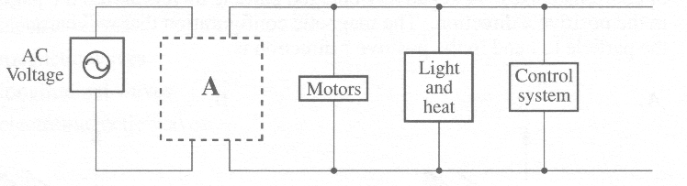

- The component labelled A in the diagram is most likely a
A. battery
B. resistor
C. generator
D. transformer

Numerical Response

- A typical television set requires 2.00 x 10⁴ V AC for its operation. Since a television is plugged into a standard 110 V outlet, the voltage must be increased. If the ideal transformer used to increase the voltage has 1.87 x 10⁴ turns of wire on the secondary coil, then the number of turns of wire that must be placed on the primary coil, expressed in scientific notation, is b x 10^{w}. The value of b is __________.

(Record your three-digit answer in the numerical-response section on the answer sheet.)

- The diagrams below show the direction of a magnetic field relative to a set of coordinate axes. A negatively charged particle travels across the page in the positive x direction. The magnetic configuration that will cause the particle to bend in the positive z direction is
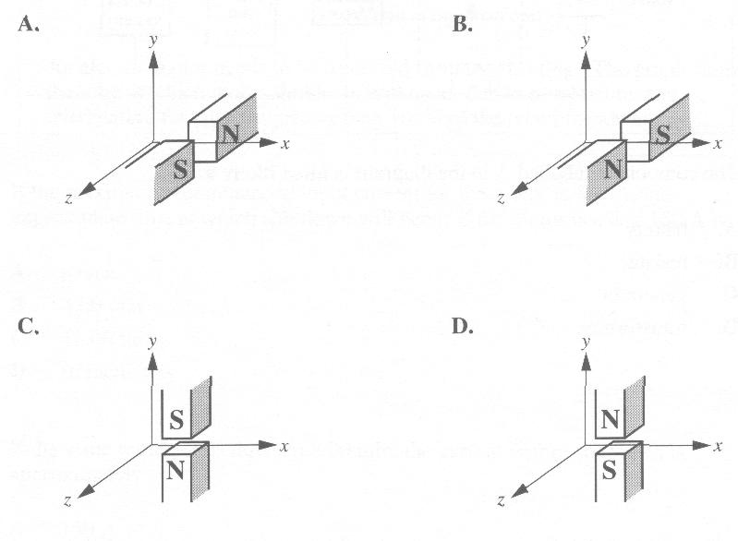

Numerical Response

- Northern lights are often observed in Alberta skies. The most common colour, green, has a wavelength of 558 nm. When a collision occurs between energetic electrons and oxygen atoms in the upper atmosphere, the oxygen atoms are excited. To cause the most common colour of northern lights, the electrons must be travelling with a minimum speed, expressed in scientific notation, of b x 10^{-w} m/s. The value of b is __________.

(Record your three-digit answer in the numerical-response section on the answer sheet.)

- Accelerating charges generate
A. electric waves
B. magnetic waves
C. longitudinal waves
D. electromagnetic waves

Numerical Response

- If a photon of electromagnetic radiation has a frequency of 1.09 x 10¹⁷ Hz, it has a wavelength, expressed in scientific notation, of b x 10^{-w} m. The value of b is ________.

(Record your three-digit answer in the numerical-response section on the answer sheet.)

Numerical Response

- An explosion that produces a flash of light occurs at a distance of 6.06 km from a group of people. The minimum possible time, expressed in scientific notation, that elapses before the people can see the explosion is a.bc x 10^{-d} s.
The values of a, b, c, and d are _____, _____, _____, and _____ .

(Record all four digits in the numerical-response section on the answer sheet.)

- Which of the following sets of electromagnetic radiations is arranged in order of increasing photon frequency?
A. Gamma rays, ultraviolet radiation, radio waves
B. Radio waves, ultraviolet radiation, gamma rays
C. Gamma rays, radio waves, ultraviolet radiation
D. Radio waves, gamma rays, ultraviolet radiation

Use the following information to answer the next three questions.

A cyclotron is a particle accelerator used to investigate subatomic structure. Magnetic fields are used to control the path of charged particles within a cyclotron.

- The radius of the path followed by charged particles moving perpendicularly through the magnetic field of a cyclotron could be reduced by
A. increasing the strength of the magnetic field
B. using particles with a smaller charge
C. increasing the speed of the particles
D. using particles with a greater mass

- The period T for a particle of charge q in a magnetic field of strength B is
A. 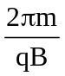
B. 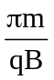
C. 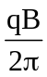
D. 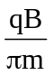

- An alpha particle travels in a direction perpendicular to a magnetic field of strength 1.6 T. If the alpha particle experiences a force of magnitude 1.1 x 10⁻¹³ N, then its measured speed will be
A. 2.1 x 10⁻⁷ m/s
B. 4.3 x 10⁻⁷ m/s
C. 2.1 x 10⁵ m/s
D. 4.3 x 10⁵ m/s

Use the following information to answer the next question.

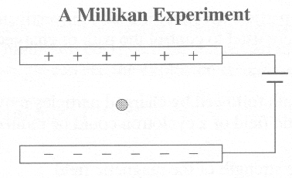

A potential difference of 12.0 V is maintained between two parallel metal plates that are 5.00 cm apart.

Numerical Response

- A mass with a +1.00 elementary charge placed between the plates will experience an electric force, expressed in scientific notation, of magnitude b x 10^{-w} N. The value of b is _________.

(Record your three-digit answer in the numerical-response section on the answer sheet.)

___________________________

- X-rays may be focused using
A. magnetic fields
B. electric fields
C. either electric or magnetic fields
D. neither electric nor magnetic fields

- In a photoelectric experiment, the maximum kinetic energy of photoelectrons does not depend on the
A. work function of the emitting material
B. wavelength of the incident light
C. intensity of the incident light
D. energy of an incident photon

- Copper has a work function of 4.46 eV. What is the maximum kinetic energy of the ejected electrons if the metal is illuminated by light with a wavelength of 450 nm?
A. 2.72 x 10⁻¹⁹ J
B. 4.42 x 10⁻¹⁹ J
C. 7.14 x 10⁻¹⁹ J
D. 0 J, because no electrons are ejected

- Louis de Broglie proposed that
A. the energy absorbed by an atom is the same as the energy released by an atom
B. if light has particle properties, then particles have wave properties
C. the intensity of light controls the current in the photoelectric effect
D. energy and mass are related

- A burglar knows that an alarm in a certain museum makes use of the photoelectric effect. Ultraviolet light shines on a photocell with a work function of 5.01 eV. Any break in the light will set the alarm off. The burglar realizes that if he shines his own ultraviolet light source at the photocell, he can ensure that there is no break in the light and that the alarm will not be set off. He obtains an ultraviolet light source with a frequency of 1. 13 x 10¹⁵ Hz. Will he be successful in his burglary attempt and why?
A. No, because the frequency of the burglar's light is too low for the photocell to function.
B. No, because the frequency of the burglar's light is too high for the photocell to function.
C. Yes, because the frequency of the burglar's light is low enough for the photocell to function.
D. Yes, because the frequency of the burglar's light is high enough for the photocell to function.

Use the following information to answer the next two questions.

Robert Millikan showed experimentally that Einstein's photoelectric equation E_{kmax} = hf – W was valid. Using a variety of cathode materials, he measured the maximum kinetic energy of photoelectrons while varying the light frequency. The graph shown is typical for a particular cathode. The dotted line is an extrapolation (extension) of the experimental data.
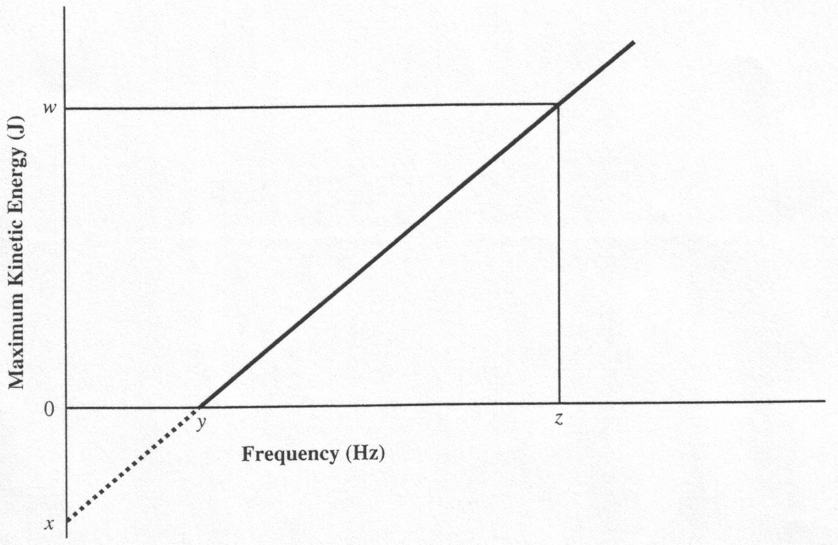
The letters w, x, y, and z represent experimental or extrapolated data.

- The value for Planck's constant could be determined with the expression
A. 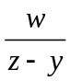
B. 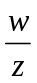
C. 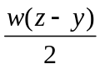
D. 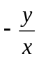

- The work function of the cathode material is equal to the expression
A. 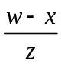
B.
C. –x
D. y
___________________________

- An atom has energy states E₁ = – 4.8 eV, E₂ = – 2.4 eV, E₃ = –1.2 eV, E₄ = – 0.80 eV, and E₅ = – 0.40 eV. The wavelength of emitted light when an electron in the atom makes the transition E₄ to E₁ is
A. 2.6 x 10⁻⁷ m
B. 3.1 x 10⁻⁷ m
C. 1.6 x 10⁻⁶ m
D. 5.0 x 10⁻⁶ m

Use the following information to answer the next question.

In December 1994, research physicists in Darmstadt, Germany, announced that they had detected three atoms of a new element. With 111 protons and 161 neutrons, this lab-made element had the highest atomic number known to that date. To create element 111, the physicists bombarded bismuth atoms, which have 83 protons, with a beam of nickel atoms, which contain 28 protons. Signals of the three atoms of element 111 appeared for less than two-thousandths of a second. The atoms then decayed into lighter elements and alpha particles. One of the isotopes produced in the decay was element 107 with a mass number of 264. This isotope had never previously been observed.
Note: Because neither element 111 nor element 107 had been officially named, element 111 was referred to as X and element 107 was referred to as Y.

- The overall nuclear equation for this decay reaction is

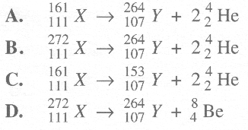
Use the following information to answer the next three questions.

Smoke Alarm
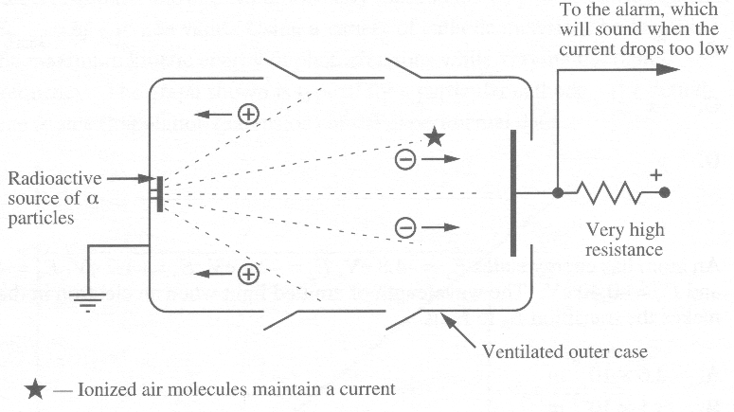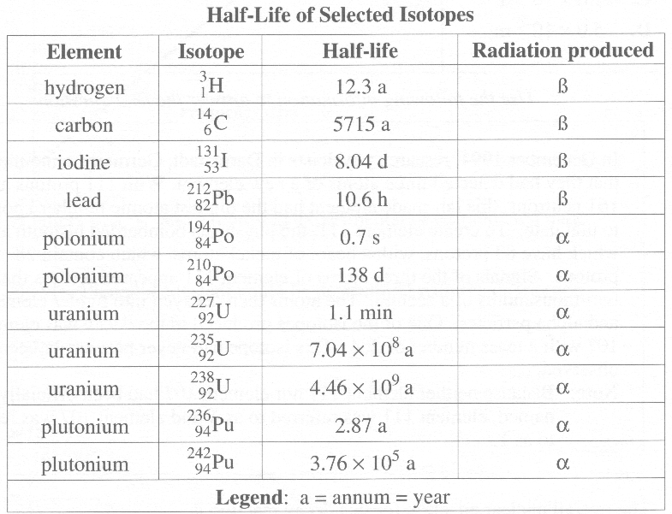

- Given the specifications of this smoke alarm, which of the following isotopes could be used as a radioactive source?
A. 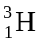
B. 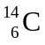
C. 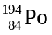
D. 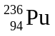

- The product of the alpha decay of 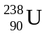 is
A. 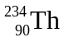
B. 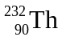
C. 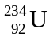
D. 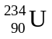

Numerical Response

- Tritium (), an isotope of hydrogen, was once used in some watches to produce a fluorescent glow. Assuming that the brightness of the glow is proportional to the amount of tritium present, the length of time it would take for the watch to reach ¼ of its original brightness is _______ years.

(Record your three-digit answer in the numerical-response section on the answer sheet.)

- To calculate the amount of energy given off during a fusion reaction, the equation that should be used is
A. E = hf
B. E =1/2 mv²
C. E = mc ²
D. E = h/t

1. An astronaut has just landed on an unknown, uninhabited planet and has to send some information about the planet back to Earth. Assume the astronaut has all of the equipment needed to perform the necessary experiments.

Using physics concepts as well as any related formulas, describe procedures that could be used, and the equipment required, in order to:

- measure the magnitude and direction of the gravitational field at the astronaut’s location on the unknown planet
- determine whether or not there is an electric field at the location and, if there is, to determine its magnitude and direction
- determine whether or not there is a magnetic field at the location and, if there is, to determine its direction

(6)

